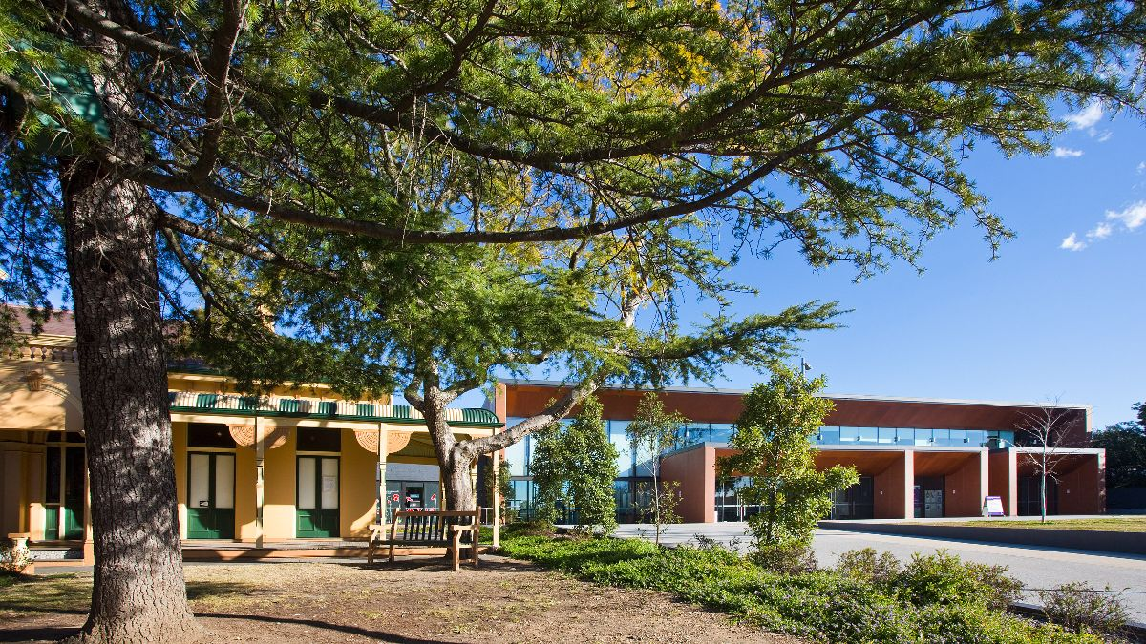

**Braemar Gallery +   
The Upstairs Gallery  
2025 Exhibition Application Form**

Key Dates

Applications open Thursday 5 September 2024

Applications close 11.59pm Sunday 6 October 2024

Program announced November

Who can exhibit?

Potential exhibitors may be artists having a solo exhibition, those wishing to share the space with other artists, group exhibitions and community group exhibitions. Exhibitors must be local artists living within the Blue Mountains local government area. For group and community group exhibitions, please appoint a Group Coordinator who will represent the group and liaise with the Braemar Gallery Management Committee.

How is selection made?

In order to provide a fair and transparent process, your application will be assessed by the Braemar Gallery Management Committee using the approved evaluation criteria listed in the ‘Braemar Gallery Application Guidelines’ and ‘The Upstairs Gallery Application Guidelines’. The Committee reserves the right to accept or refuse exhibition submissions at its discretion. If accepted, you will be notified of possible dates, and leading up to your exhibition, receive further documents to be completed and returned.

What costs are involved?

**Braemar Gallery**As of 10 November 2015, Blue Mountains City Council has made Braemar Gallery available free of charge to exhibiting artists. Braemar Gallery will provide limited install materials, subject to negotiation and confirmed by the Exhibition Coordinators at the Artists Briefing Meeting held six weeks prior to the exhibition. Generally this includes hanging wires, gallery lighting, gallery plinths and artwork numbering. Should extraordinary display materials be required, these will be the responsibility of the exhibiting artists and will need to be approved by the Exhibition Coordinators.

**The Upstairs Gallery**It is available free of charge to exhibiting artists. Hanging rails and installation support will be provided to artists.

Public Sculpture Program

Separate to the exhibition program inside the gallery, Braemar Gallery also accepts Expressions of Interest for sculptors to exhibit upon the lawns of Braemar House for the Public Sculpture Program. Guidelines and Expression of Interest forms are available on the website here: <https://www.bluemountainstheatre.com.au/braemar-house/opportunities/>

How to apply­­­

* All applications to exhibit at Braemar Gallery and The Upstairs Gallery **must be using this Application Form and submitted by 11.59pm on Sunday 6 October.**
* Applications that do not adhere to this template will be rejected. Partially completed applications will not be assessed.
* We ask applicants to prepare their application as follows:

1. Download this Word Application Form and answer each question using the existing formatting (Myriad Pro, size 11 font etc) and keeping to the prescribed word limits.
2. Save the document as a PDF, attached the PDF and support materials to an email and send it to [braemargallery@gmail.com](mailto:braemargallery@gmail.com). Please put “X Exhibition Application” followed by your name and preferred gallery in the email subject line.

* Email is our preferred method of receiving applications, however, you may post your application with images on USB to the below address:

The Exhibition Coordinator  
Braemar Gallery

Blue Mountains Cultural Centre

Locked Bag 1005

KATOOMBA NSW 2780

* **Postal applications must be received by COB on Friday 4 October.** Please do not send original artworks.
* Please provide images as jpeg files or pdf. Images must be clearly numbered, corresponding to the below list. Image size should be 200-300dpi and not exceed 3MB. Files may be zipped/compressed to reduce email size.
* Please ensure your application does not exceed 10MG.
* Assistance in completing applications can be provided by emailing: [braemargallery@gmail.com](mailto:braemargallery@gmail.com) and put “Request for assistance with application” in the email subject line or phone the Cultural Centre on 4780 5410 and leave a message for the Braemar Gallery Administrator. Please note this role works part time on Thursdays and Fridays.

Applicant(s)

**Name:** Type here

*(or group/ organisation name. Please provide contact details for group)*

**Postal address:** Type here

**Phone:** Type here

**Mobile:** Type here

**Email:** Type here

**Website:** Type here

**Are you applying to exhibit at:** Braemar Gallery  The Upstairs Gallery

*(Please check the embedded check-box. You may select both. Please be aware that this space may not be suitable for all exhibitors. Refer to the exhibition guidelines documents for details.)*

**If applying for Braemar Gallery, how many rooms would you like?** 1  2  3    
*(Please check the embedded check-box. Please note that you may not be allocated the number of rooms you have requested)*

**Do you wish to use the verandah?** Yes  No   
*(This is in addition to the Exhibition’s official opening. Please check the embedded check-box)*

**Please indicate if there is a reason you prefer your exhibition to be around a particular date.   
For example, anniversary event or mental health week.**

Type here

**Signed by the artist or group representative**

**Signature:** (e-signature) **Date:** Type here

*(Please use an electronic signature if possible or otherwise, print, sign and scan.)*

Admin use only   
Received by: Date:

Exhibition details

**Exhibition Title** Type here

**Exhibition Description**

*Describe the proposed theme/concept and medium used. For community/group exhibitions this statement needs to outline the theme for the exhibition, participating artists, number and medium of works. ­(****Maximum 300 words.)***

Please type response in here.

Support Material

1. Please list below details of the digital images provided with your application. Images can either either be inserted into the form or supplied as attachments in the email. A minimum of 8 and a maximum of 10 images are required for solo exhibitions, or up to 5 images per artist but no more than 20 in total for group/community exhibitions.
2. Provide a CV relevant to your artistic practice (Maximum of 2 A4 pages). In case of a group application please provide a paragraph bio or CV for each artist.

| **Title and Artist** | **Year** | **Medium** | **Dimensions  in cm  (h x w x d)** |
| --- | --- | --- | --- |
| 1.  *Key image. This image will be used for promotional purposes* |  |  |  |
| 2. |  |  |  |
| 3. |  |  |  |
| 4. |  |  |  |
| 5. |  |  |  |
| 6. |  |  |  |
| 7. |  |  |  |
| 8. |  |  |  |
| 9. |  |  |  |
| 10. |  |  |  |