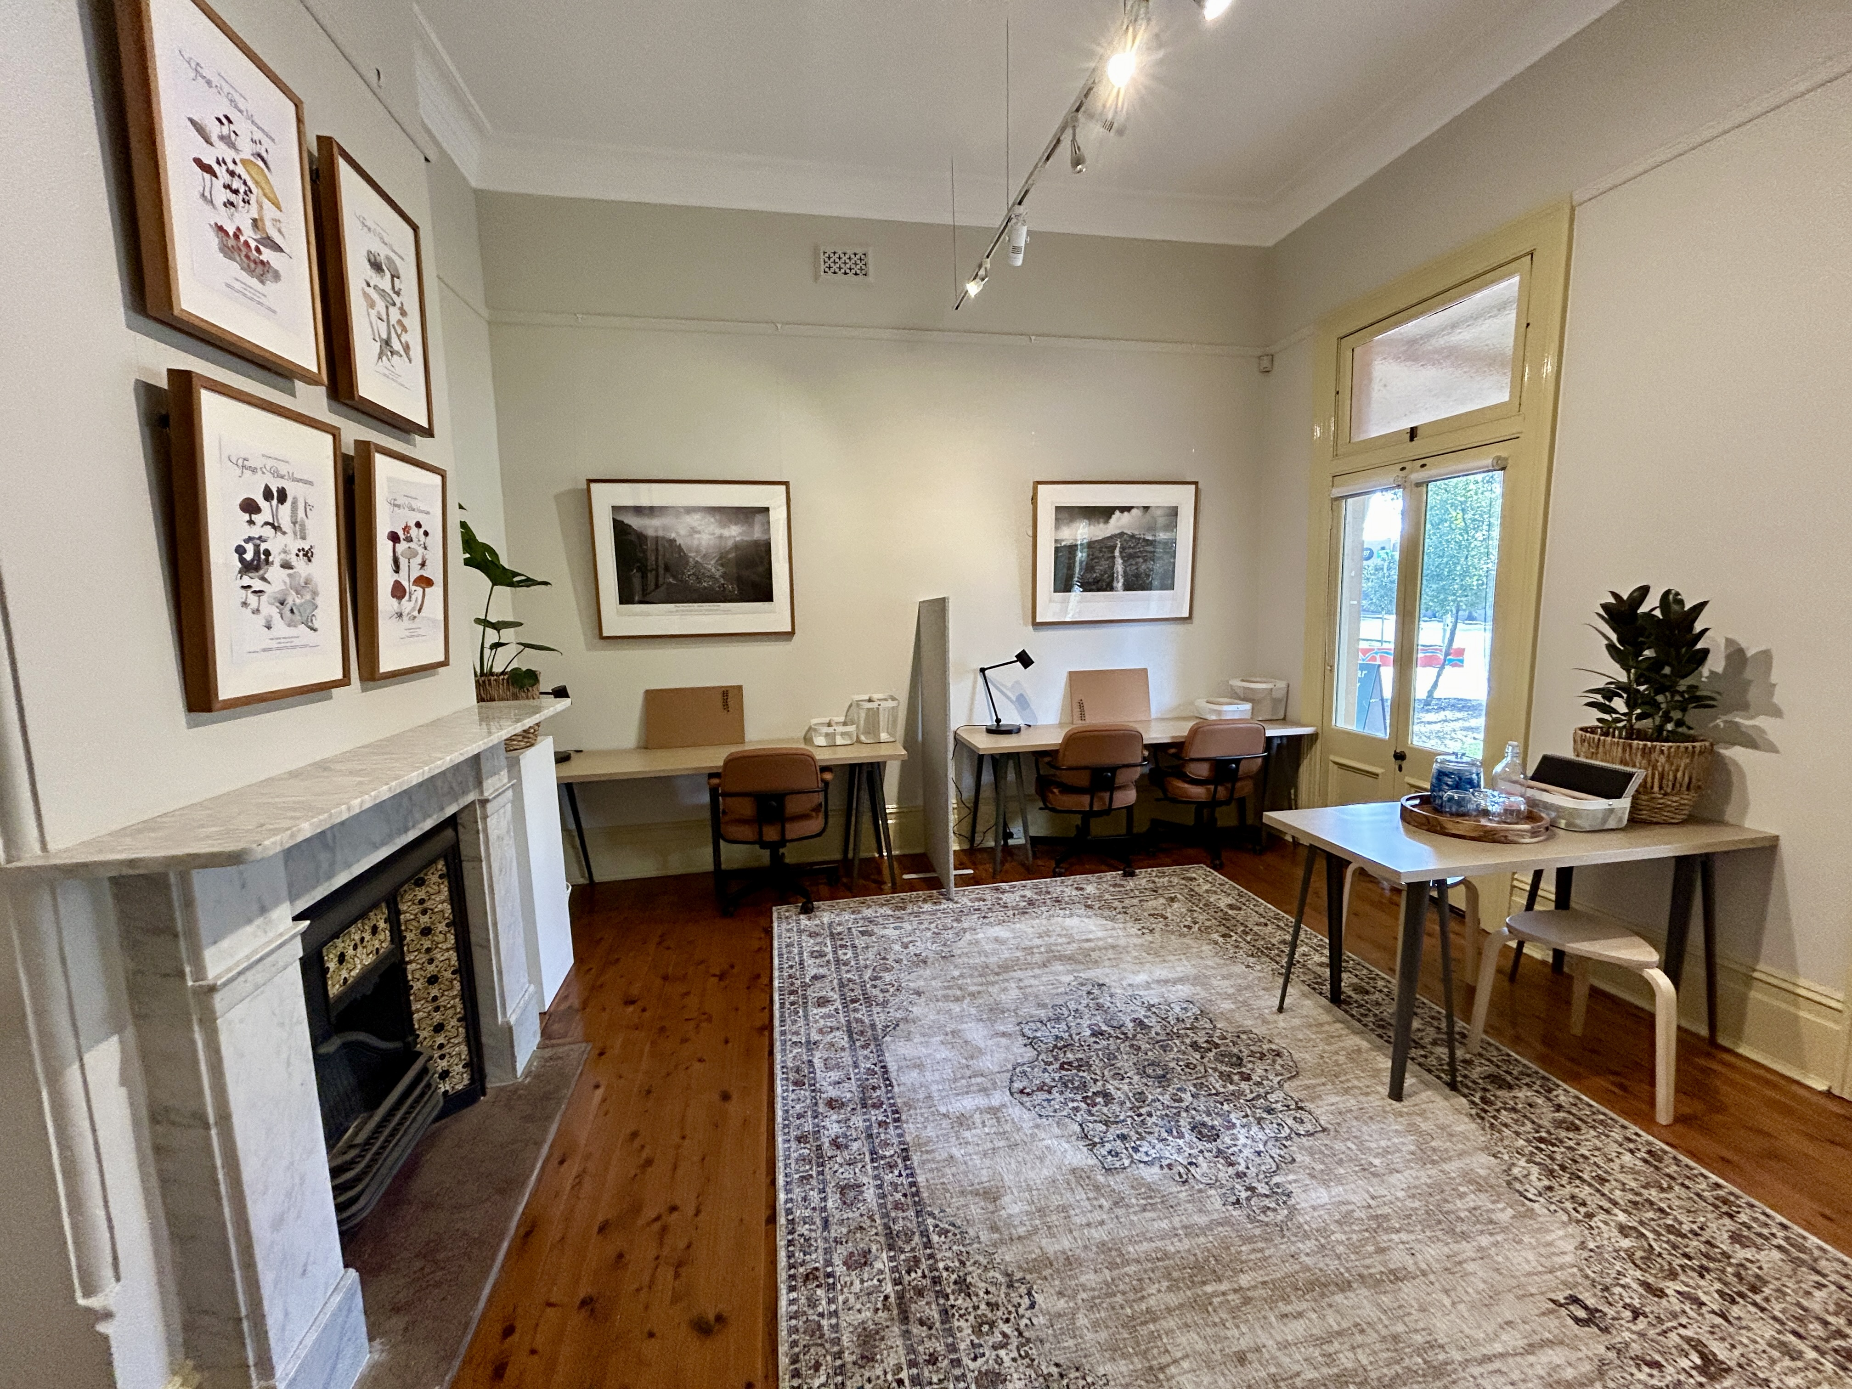

Braemar House
Creative Spaces Pilot Program
Overview and Application Form



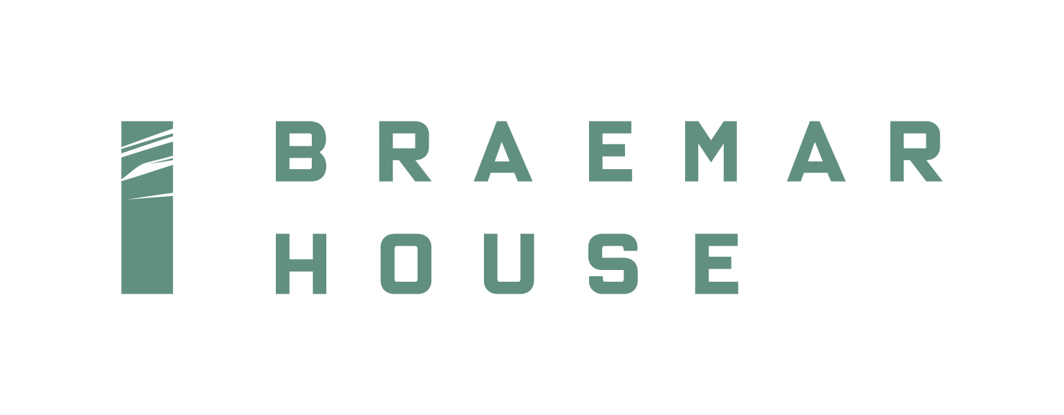

Introduction
Braemar House is a heritage property, and an arts and culture facility managed by Blue Mountains City Council’s Cultural Development Team. It forms part of the Blue Mountains Theatre and Community Hub precinct in Springwood.
The historic building is home to a volunteer-run community gallery supporting Blue Mountains visual artists and three new Creative Spaces co-working studios.
Braemar House Creative Spaces are for desk-based artists, designers and producers and as a way of connecting individuals, building networks and exploring opportunities for the creative community.
Pilot program
In October 2024, we are inviting local creative people to apply for the Braemar House Creative Spaces Pilot Program where we will be trialling co-work space usage and seeking feedback from participants to help shape a formal program in 2025.
Selected participants will receive a co-working space free of charge until the end of the pilot period. Following that trial, we will formally launch the program with a fee structure from mid-2025.
To ensure a co-work environment is established, we will not be accepting ad-hoc hot-desking and meeting bookings.

Available spaces
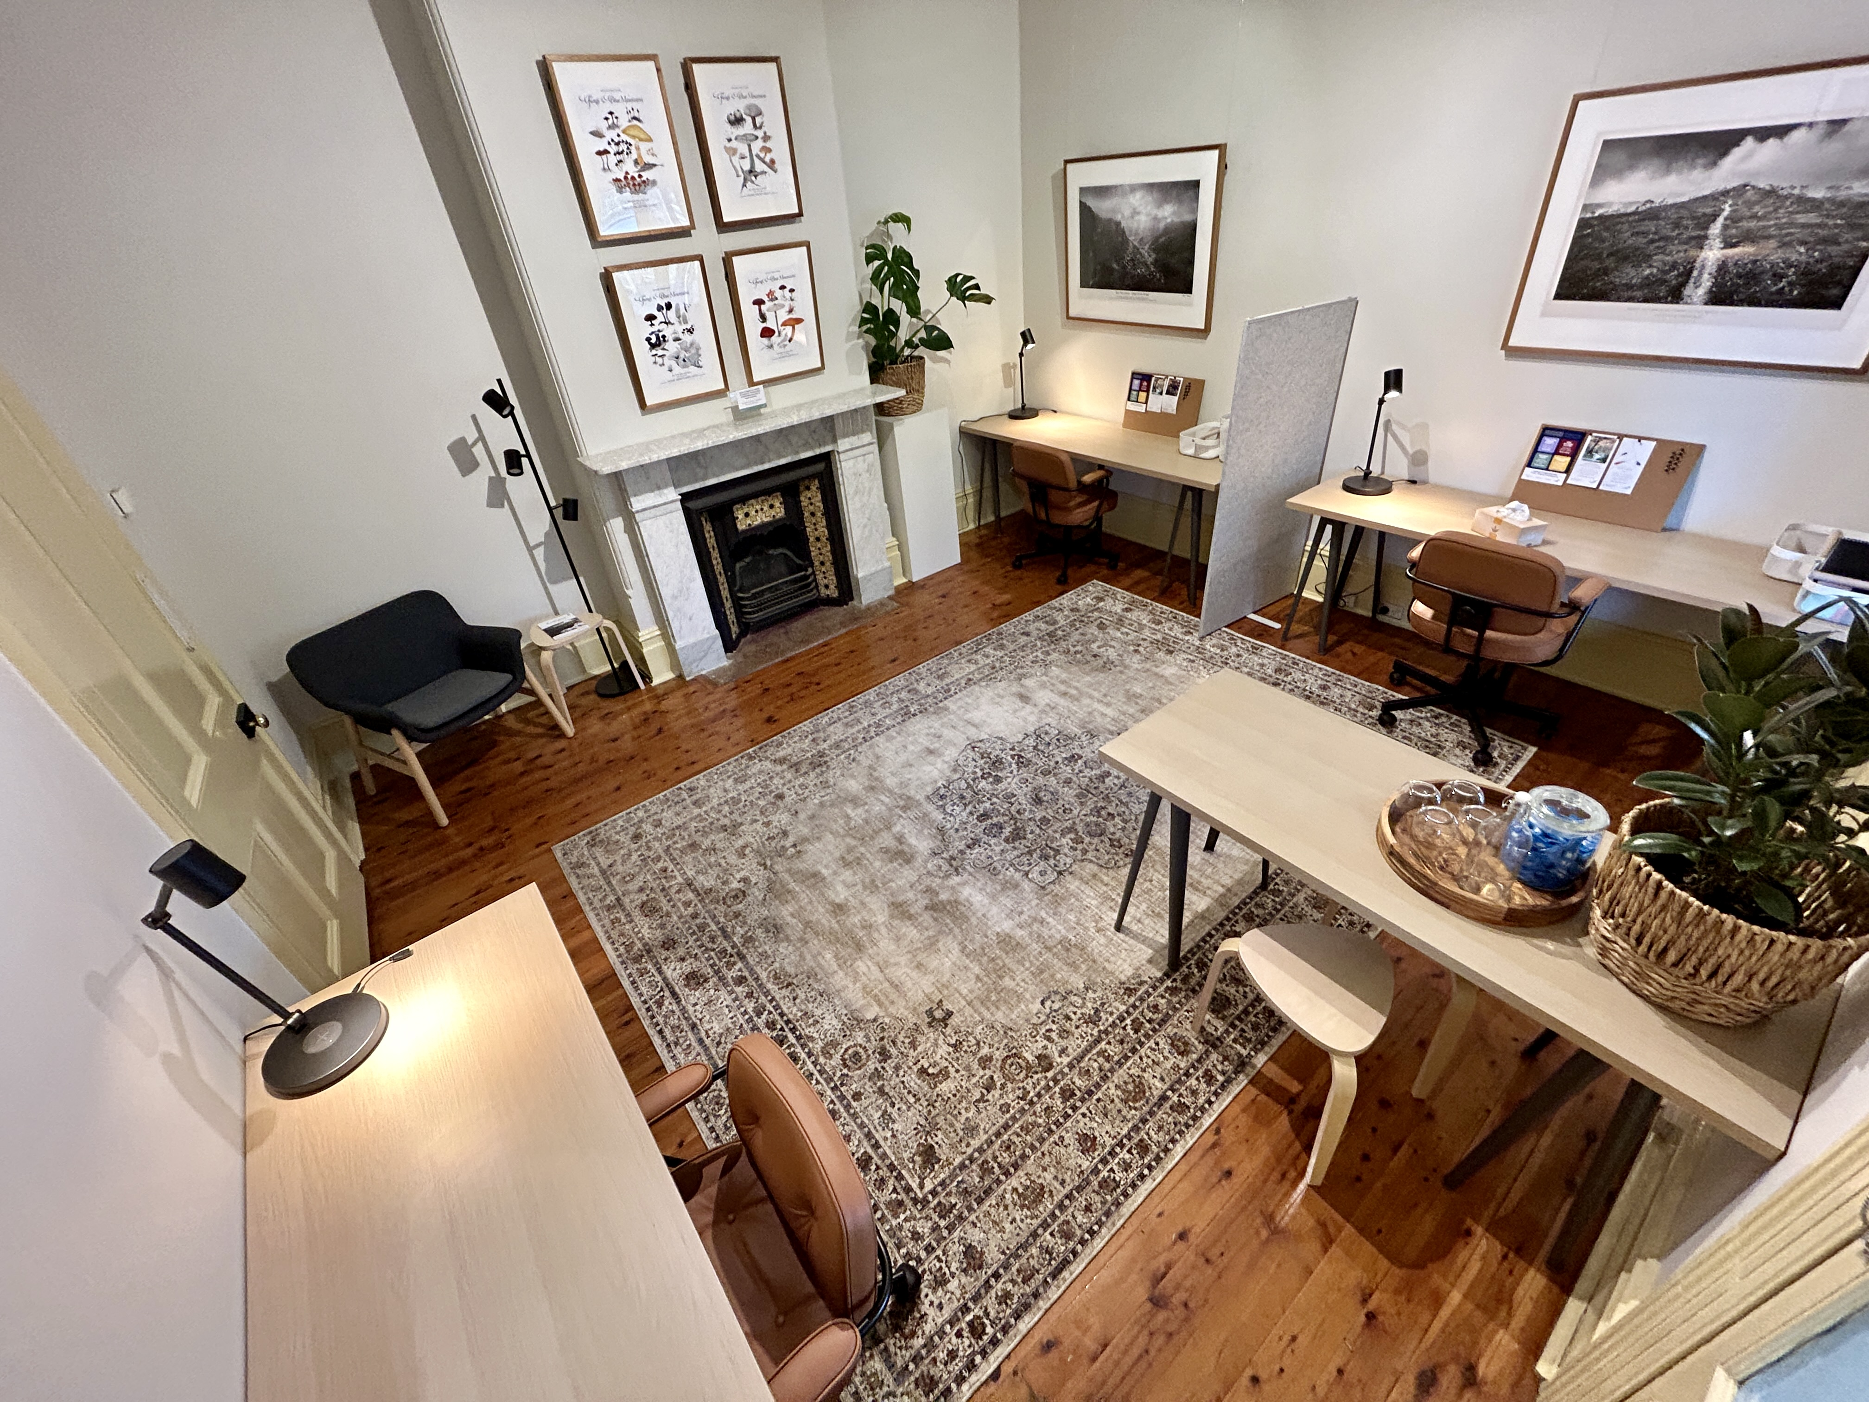 | Banksia (4.42m x 4.5m)  This room is situated at the front of Braemar House with a view onto the verandah and sculpture garden. It is the largest of the rooms and includes three desk spaces and a common table and armchair. The room is flooded with natural light, features a heritage fireplace, and has been freshly painted and decorated. Banksia is available as a co-work space.
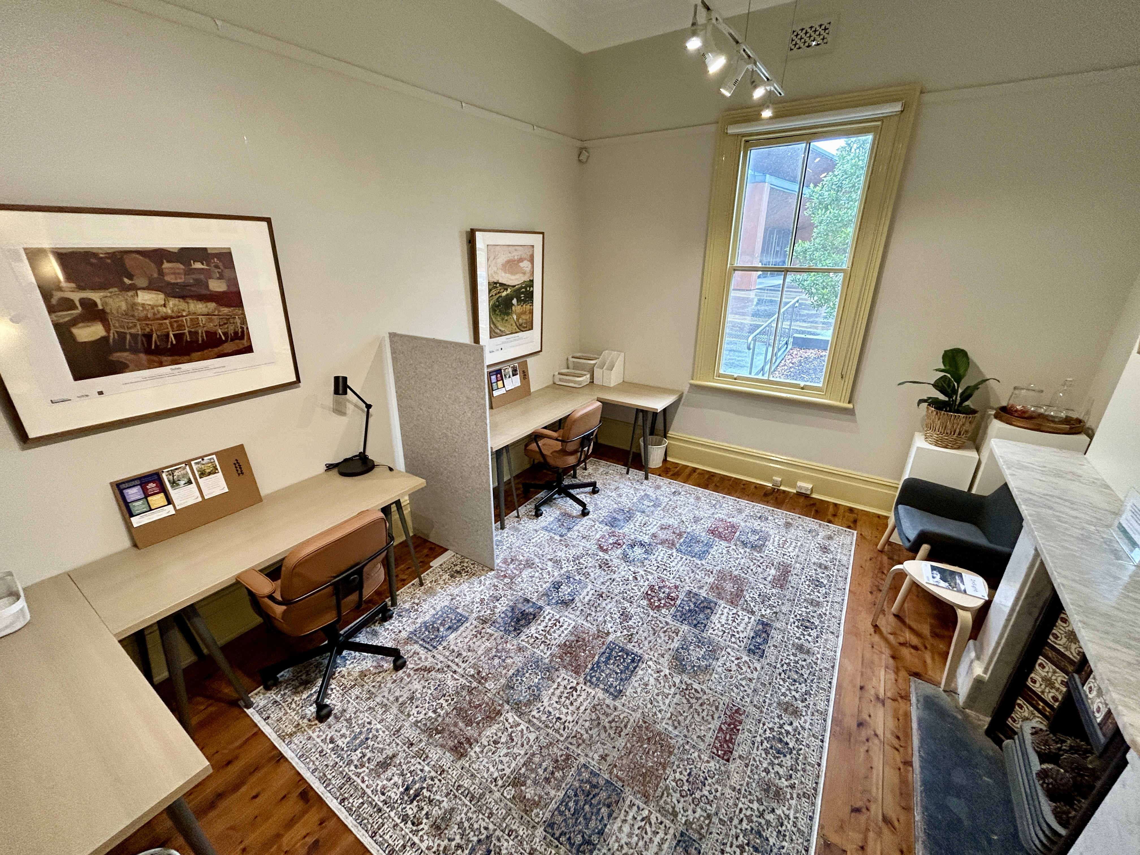 | Eucalyptus (3.75 x 4.5m)  This room has views onto the Blue Mountains Theatre and Community Hub forecourt. It is the mid-sized room and includes two desk spaces and a common armchair. The room is flooded with natural light, features a heritage fireplace, and has been freshly painted and decorated. Eucalyptus is available as a co-work space.
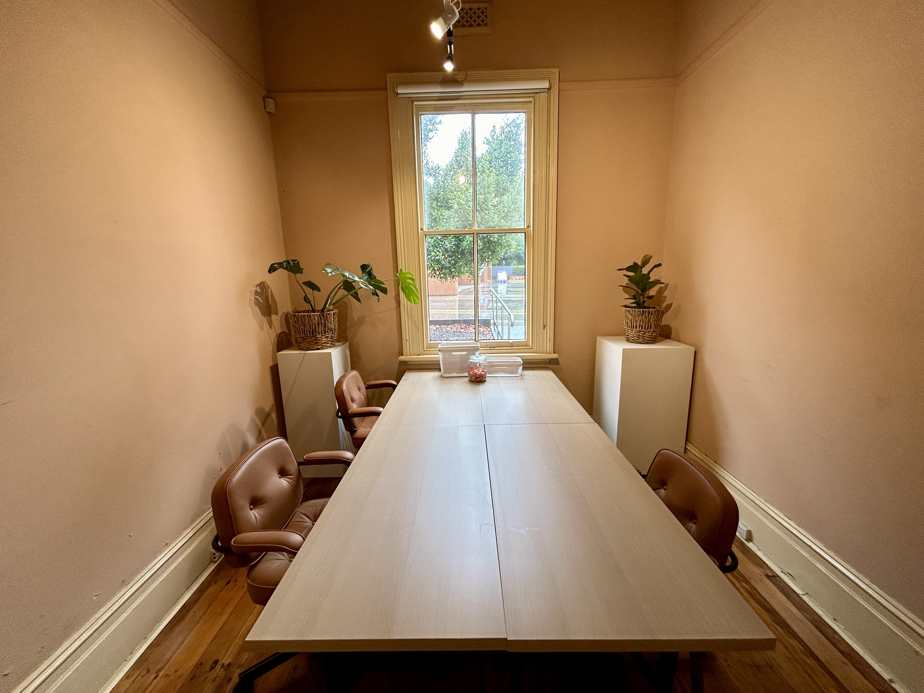 | Waratah (2.95m x 4.5m)  This room has views onto the Blue Mountains Theatre and Community Hub forecourt. It is the smallest room and includes four desks currently configured into a common table. It will be repainted and decorated in early 2025. Waratah is available as a private studio space.
Inclusions
All selected occupants will have access to:
- high-speed internet;
- basic stationery supplies;
- kitchenette with mini fridge, hot water system, snacks, tea and coffee; and
- a unisex bathroom.
All rooms are fitted with air-conditioning and accessed via the heritage hallway shared with the gallery. Pin boards and white boards are available on request.

General terms of use during pilot program
- Use of the creative space will be free of charge for the selected participants.
- The pilot will end on 30 June 2025. A formal program will then be launched and fees will be charged.
- Access to the rooms will be from 8am to 8pm seven days per week.
- Artists / creatives must be 18 years or over to apply.
- Artists / creatives will be selected from an application process. Once selected, they must enter into a licencing agreement and receive a site induction prior to commencement of their occupancy.
- An access key will be made available with a $150 bond payment (funds will be released at the end of the occupancy period subject to terms of the agreement).
- Artists / creatives may bring one collaborator on site during the licensed hours unless previously agreed with the Cultural Development team. The artists / creatives are responsible for the conduct of any collaborators they allow on site.
- Artists / creatives must consider others when using the space including other artists / creatives, gallery volunteers and members of the public.
- Artists / creatives are responsible for keeping their space clean and tidy, washing up communal kitchen items etc, and returning the space to the same condition after the contract ends.
- Artists / creatives understand that Braemar House and adjoining galleries are open to the public from 10am to 4pm Thursday to Sunday.
- Unauthorised or improper use of the space may result in the contract being terminated.
- Other than registered service dogs, animals will not be permitted inside Braemar House.
- Artists / creatives are responsible for their personal belongings while occupying their space.
- Artists / creatives are to provide a certificate of currency for public liability insurance with cover up to $20 million. Individuals without PLI are recommended to seek advice, e.g. from the National Association for the Visual Arts (NAVA).

Desired selection criteria for applicants
- You should be a desk-based artist or creative industry professional residing in the Blue Mountains LGA;
- Your art / creative practice is appropriate to a communal work environment and you would like to contribute to a community space;
- You intend to use the space for your artistic / creative practice;
- You endeavour to use your space for a minimum of 24 hours per week to ensure effective usage and help establish a community work place;
- You should be willing to provide feedback during and at the end of the pilot.
Application process
Applications will be reviewed on a monthly basis by an assessment panel based on the above desired selection criteria and any additional information provided. An offer will be made subject to your application meeting the criteria and space availability.
The Cultural Development Team reserves the right to decline an application for any reason.
Completed applications should be submitted to culturaldevelopment@bmcc.nsw.gov.au 11.59pm Sunday 10 November 2024. We welcome the opportunity to answer any questions regarding the application form or process. Tours of the spaces are also available on Thursdays or by request.

Application form – page 1 of 2

Name
Residential address
Phone
Website / Facebook
- Why do you want to be part of this pilot program? (max 50 words)
- Please summarise your art form or creative industry (max 50 words). Please provide examples of your work (web links, hard copies or attach to email (max 10MB)
- Please explain how you intend to use the space should you be made an offer (max 50 words)
- How many hours do you intend to use the space each week?
- I am willing to provide feedback during and at the end of the pilot.

Application form – page 2 of 2

Space request | ☐ one desk  ☐ a private studio
Period of use | ☐ one month  ☐ three months  ☐ until 30 June 2025
Preferred start date from Monday 25 November
Please let us know if you have any additional needs including accessibility requirements
Date
Signature

